Vivado Crashing Issue

# Specifications:

* **Vivado version:** 2018.2
* **Operating System:** Ubuntu 22.04.1 LTS
* **Computer:** Lenovo V15 G2 ITL

# Issue Details:

After updating from ubuntu 20.04 LTS to ubuntu 22.04 LTS, Vivado started crashing while changing the file type. To reproduce the issue one may do the following:

* Right click on one of the project files.
* Select option “Select File Type”
* Press the drop down arrow on the pop-up box.

This issue may also be reproduced by doing the following:

* Open the project settings in the project manager.
* Wait for a few seconds.

# Diagnosing the error:

The issue can only be correctly diagnosed by launching the vivado from terminal as on the crash, the terminal displays a message about an abnormal crash and will refer to the file in which the issue will be logged. In my case the error log file was stored in the same directory in <Xilinx_install_dir>/Vivado/2018.2 with the name hs_err_pid14583.log. The contents of the file may look as follows:

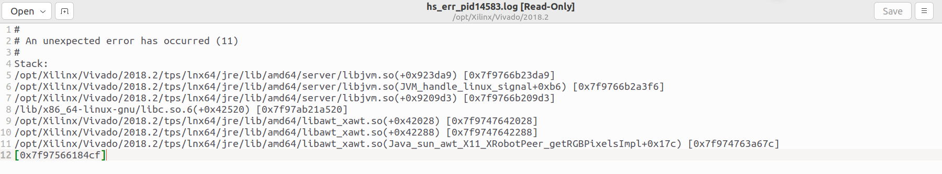

From the first line we can see that the error is in the directory related to jre (Java Runtime environment).

# Resolving the issue:

A similar issue was reported in [this](https://support.xilinx.com/s/question/0D52E00006hpi31SAA/unexpected-error-has-occured-11-vivado-20182?language=en_US) Xilinx Forum and a solution was proposed by ***krishnan***. The contents of the post are as follows:



One thing to note is note that the file is not stored with the name of *syntheticPlain.jar* rather it is stored with the name *syntheticaPlain.jar* and the location in my case was */opt/Xilinx/Vivado/2018.2/lib/classes.*

# Conclusion:

Following above solution solves the problem as tested on 29-08-2022 and it the issue does persists using above mentioned methods for reproducing it. It may not solve issues related to crash where the cause is different.